Make a prayer card for your grandparent!
- Choose a special saint of our faith
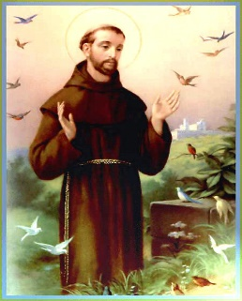
This Photo by Unknown Author is licensed under CC BY-NC-ND
(e.g. St. Anthony, St. Monica, St. Francis, St. Elizabeth Ann Seton)

- Find out a little bit about that saint
(where they were born, what made them a saint, their feast day)
(St. Francis of Assisi, born in Italy 1181, known as a devout follower of Jesus and someone who loved all of nature as created by God. Feast day is October 4)

- Find a prayer by that saint
(Lord make me a channel of your peace…)

- Use a piece of paper, or cardboard to make a prayer card. Draw the saint, copy the prayer, and write a little bit of information about the saint. You could make it like a sports player card!

- Give it to your grandparent and tell them why you chose that saint!

